1. **Provide a topic “KYC Report Construction for Lee Kum Kee Hong Kong Limited: Risk - Based Company Background Check and Evaluation” and hit Sumit**

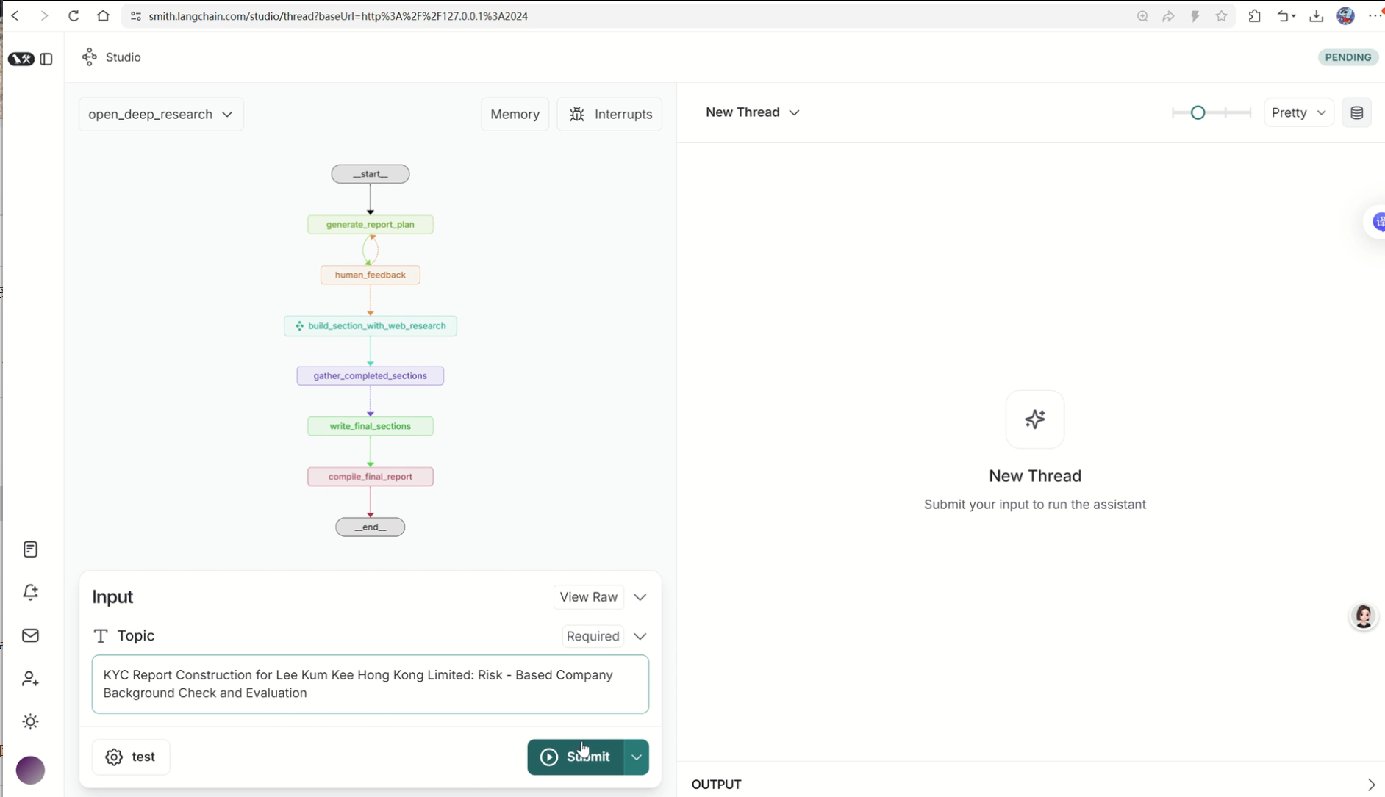

1. **This will generate a report plan and present it to the user for review.**
2. **We can pass a string (“Please include checking on adverse media”) as feedback to regenerate the plan based on the feedback**

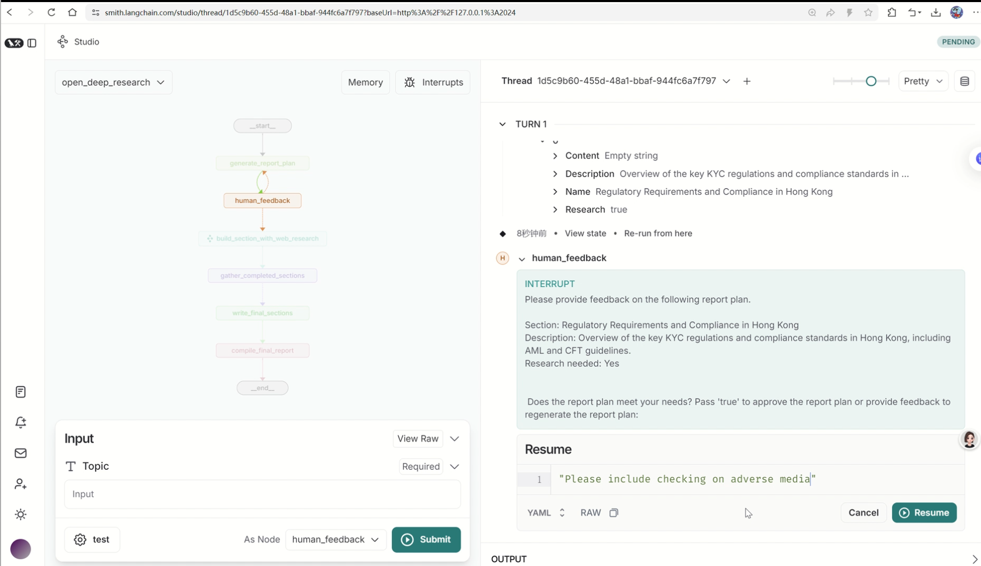

1. **Pass true to accept the plan**

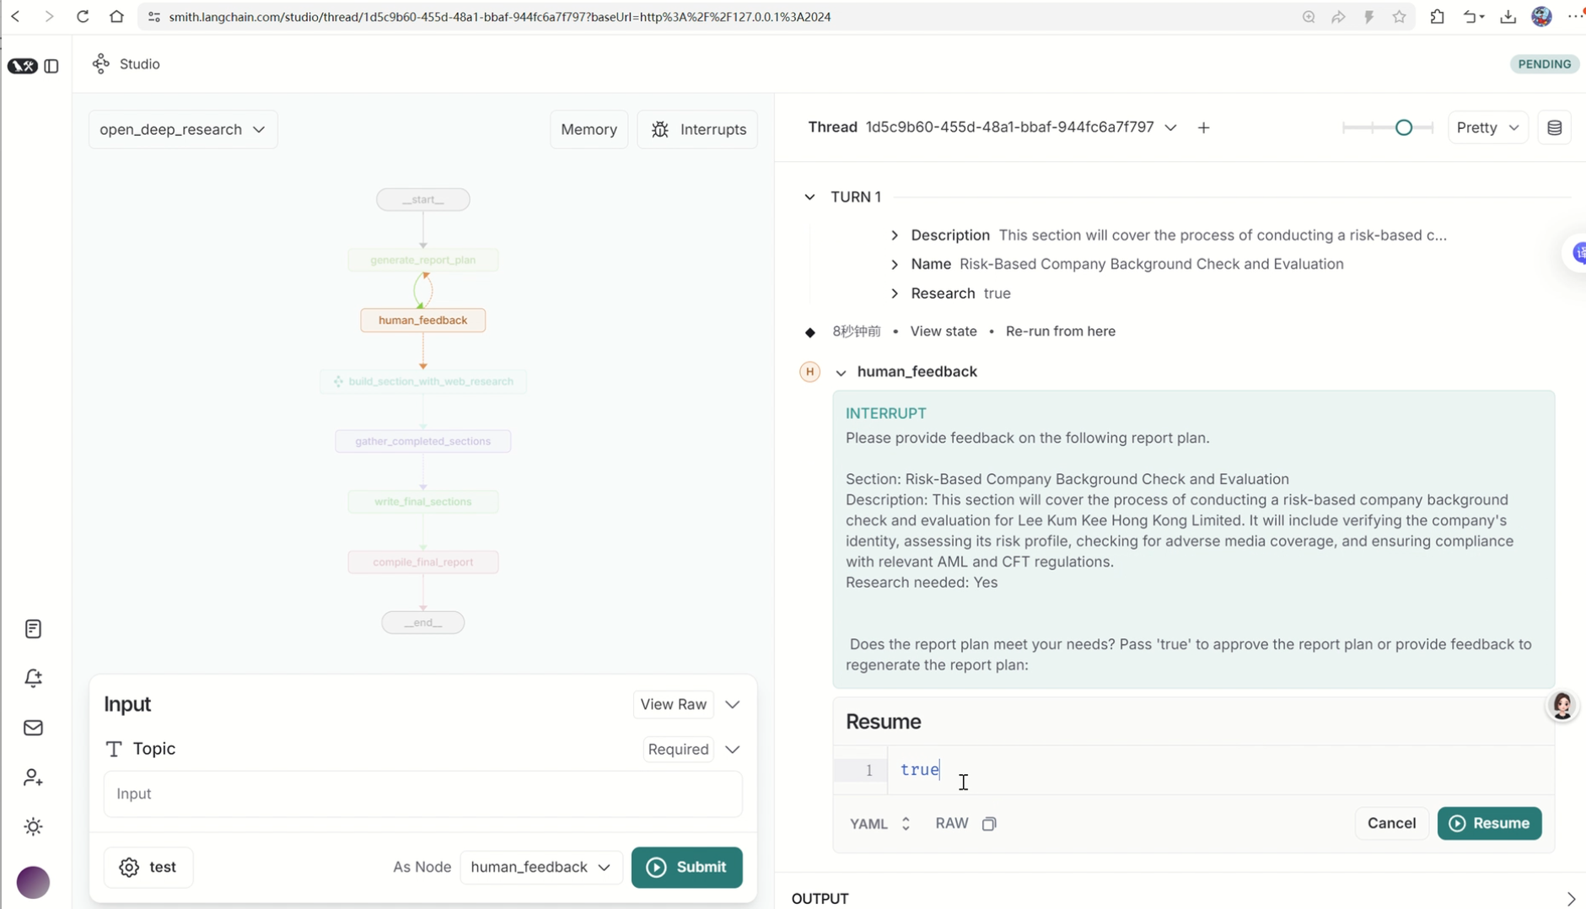

1. **Once accepted, the report sections will be generated. Here we just write one section since there is token limitation for the free AI model**

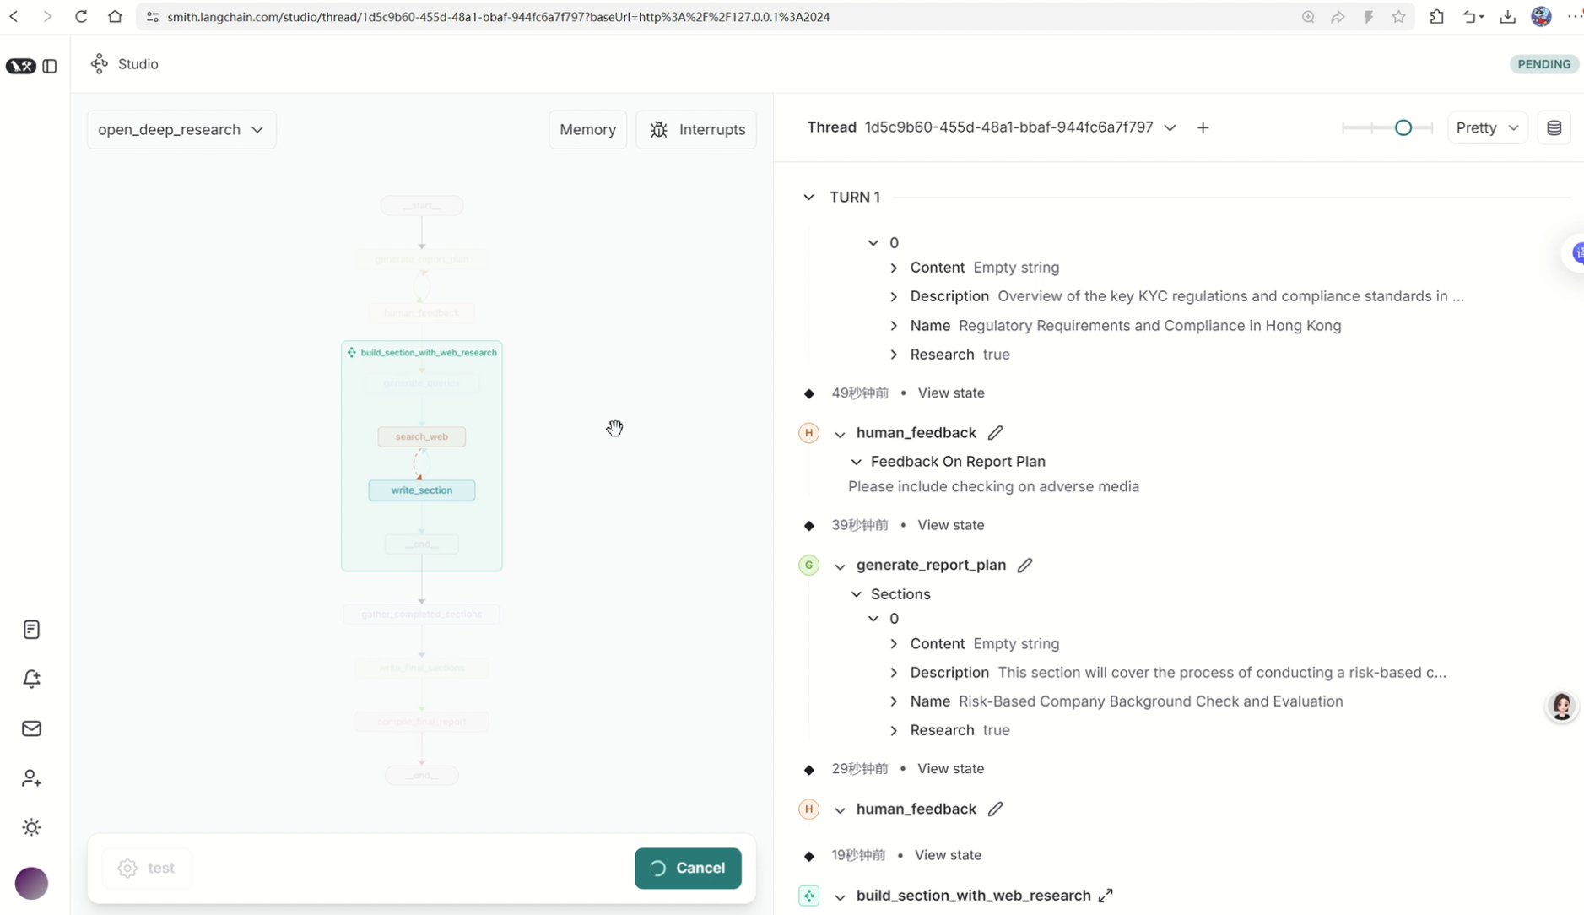

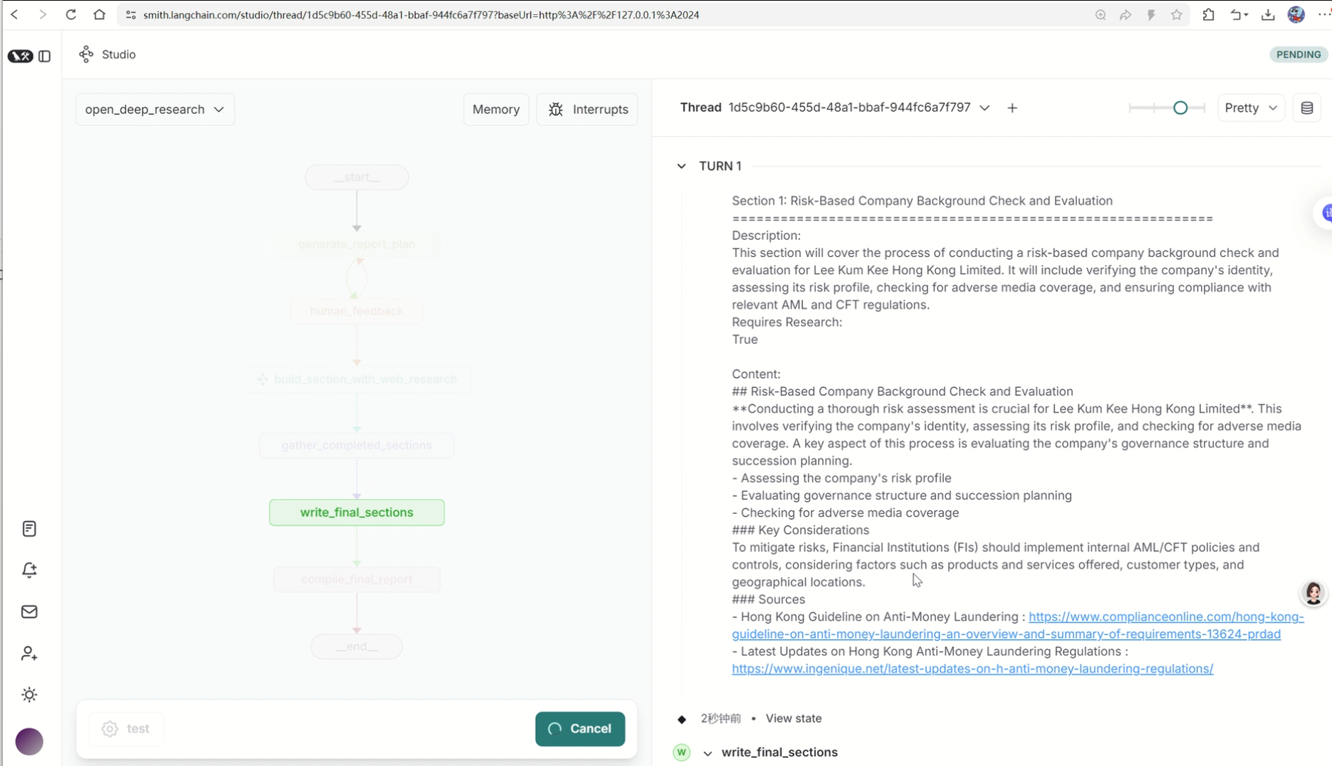

1. **The report is produced as markdown.**

